
Face Mask & PP polypropylene fabric business:

What is 3 ply
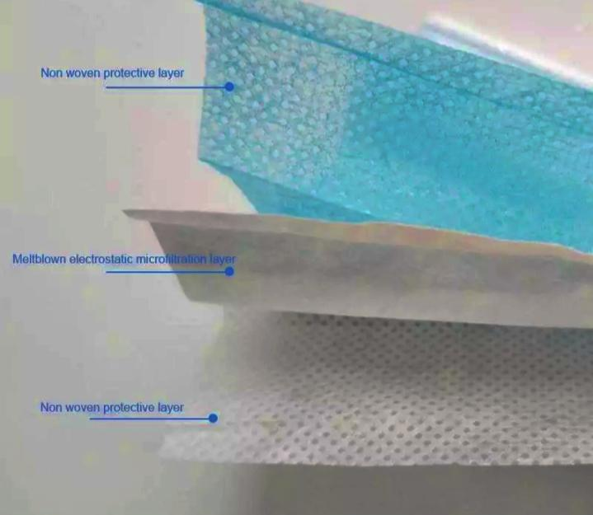
1st Layer: PP spunbond waterproof outer fabric
2nd Layer: PP melt blown filter fabric
3rd Layer: PP spunbond absorbent soft inner fabric

What is 4 ply vs N95
Some N95 masks have 2-layer meltblown, the filtering effect is 99%.
Some N95 masks are made of 5-layers design, 1-layer soft cotton, 3-layer non-woven fabric, 1-layer meltblown, the filtering effect is 95%.
A 4 ply face mask is like a 3 ply mask with an added extra layer of activated carbon filter or one more filtering layer.

PP non-woven fabric is environment friendly
Non-woven polypropylene fabrics are among the most versatile materials we have in the market today.
PP non-woven material will decompose naturally if placed outdoors and its maximum life period is only 90 days but if placed indoor it can last 5 years.
When burnt, it is non-toxic, odourless and without any residual substances. Non-woven polypropylene is eco-friendly.
Applications:
1.Therapeutic; surgical gowns, isolation gowns, surgical mask, caps, surgical covers, gloves, bath wipes, plasters and shoe covers
2. Making filters: coffee and tea bags, bag filters, mineral processing and allergen membranes
3. Geotextiles: for soil erosion control, roadway underlayment, soil stabilization and canals construction.
4. PP non-woven shopping bags which are eco-friendly in the campaign against using plastic
5. Non-woven interlining: in garments and integrated into clothing for different functions of water resistance, higher strength and consistency and rainwear goods. Diapers (babies and adults), sanitary napkins, wet sanitised wipes and other sanitary products.

PP melt blown (MB) non-woven
The meltblown non-woven is made by extruding the melted polymer fibre through a continuous die made several small holes. The liner dye forms long fibres which are stretched and then cooled by passing through hot air.
Raw material is a special high flow PP blended resin.
PP MB price fluctuated between USD30,000 to 100,000 per ton and currently near high end. The global sudden demand has unsettled the supply situation.
For each 1 million 3 ply surgical mask, it needs 1 ton of PP MB.

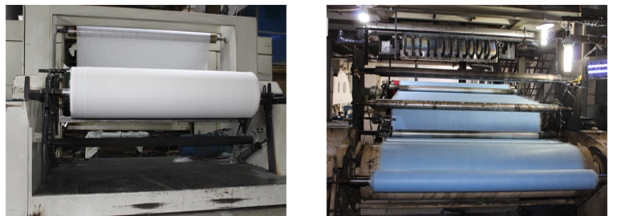

PP spunbond (SB) non-woven
The spunbond non-woven fabrics are processed using the following processes: the polymer is extruded then stretched to form a continuous filament. The filament is laid into the web and then the web is processed into a join-woven fabric through thermal biomechanical reinforcement and chemical bonding.
Raw material is PP resin and blended polyester resin and other polymers.
PP SB price ranged USD5,000 to 30,000 per ton and also at the top end of range. We expect this price to rise further when the lockdowns in many countries start and face mask is made mandatory to wear in public.
For each 1 million 3 ply surgical mask, it needs 2 tons of PP SB for the inner and outer layers.
With both PP MB and SB raw material prices jumping up, the face mask makers face a continuous onslaught of rising PP costs. That is the primary reason for Notion to move into the PP fabric business as well as an opportunity to produce and sell PP fabric to face mask makers in the export market.
Global market outlook
- Face mask market outlook:
The rise in instances of hospital acquired infections and the global Covid-19 pandemic, increasing old populace and improvement in medicinal services in developing economies are driving the growth for Non-Woven Face Mask Market.
According to MarketWatch, Polaris Market Research and Market Study Report, LLC the market intelligence firms reported the face mask industry to depict a robust growth rate CAGR of 22% from 2019 to 2026 (USD3 billion to 7.2 billion)

Global face mask market has been segmented into North America, Europe, Asia Pacific and rest of the world. USA held 29% in 2017 and next was China.

The explosive demand for face mask in 2020 may or may not be repeated in 2021 depending on the progress and availability of a vaccine or a cure and whether this new culture of mask wearing is sustained in the longer term.

Also, the vulnerability of the hospitals and front-liners due to shortage of PPE makes it compelling for building up contingency stock pile policy in case another pandemic occurs in the future.

Many countries will want invest in capacity to produce PPE instead of depending on China as main source.

- PP non-woven fabric market outlook:
PP Non-Woven Fabrics Market size was over USD24 billion globally in 2018 and estimated to grow over 10.5% CAGR between 2019 to 2026 according to Global Market Insights, Inc

Notion’s investment strategy
Face mask:
- Invested in 3 lines in Klang for output of maximum 8 million 3 ply surgical face mask per month. Operational June.
- Invested in 1 line of 4 ply medical mask in Klang for output of 4 million pieces of 4 ply face mask per month. This is meant for the export market. Operational August.
PP melt-blown fabric machinery for output:
- Invested 2 machines operational June: 20 tons per month
- Invested 2 machines operational August: 25 tons per month
- Notion will develop in-house spinneret mould and reengineer for MB production machinery in 3 months
PP spun-bond:
- This investment is delayed until the outlook is clearer as its fairly high investment cost and the capacity is also high. The output will have to cater to more than just face mask production but other downstream applications which need further market studies.

Conclusions:
Face mask est sales: RM11.2 mil a month
PP MB est sales: RM6.3 mil a month
Total estimated Healthcare Business: RM17.5 mil a month or annualised RM210 mil
Face mask local sales through distributorship and online sales whilst exports will be through in-house marketing and our customer channels.
PP MB we have ready buyers in China and also local enquiries from face mask makers.
Further expansion of this sector will be subject to progress of the supply and demand trend for face mask during this pandemic and overseas demand for both the face mask and PP MB.
Overall, Notion is still very much a metals business and it will remain core as we have solid demand orders in the HDD and we are developing the aluminium extrusion business. EMS sector is still ongoing albeit at a slower pace with new product development by customers while we wait for the global economic recovery. The Auto sector we are unsure when their future will pan out to normal.

